Autoadhesive conductive cryogel as electrode for electrical stimulation to promote skin wound healing
Shujun Cui^{1,2}, Mahmoud Rouabhia¹, Ze Zhang²
¹Groupe de Recherche en Écologie Buccale, Faculté de Médecine Dentaire, Université Laval, Québec, Canada.
²Département de Chirurgie, Faculté de Médecine, Axe Médecine Régénératrice, Centre de recherche du CHU de Québec, Université Laval, Québec, Canada
Background: Transcutaneous or transdermal electrical stimulation is the technique that uses electrical field to noninvasively stimulate muscle or nerve through multiple electrodes patched to the skin. Existing devices include transcutaneous electrical nerve stimulation (TENS). The electrodes used by these devices are made of metal, carbon- or graphene filled silicone, or self-adhesive gel. They are all in form of small pads and not suitable to surround a skin wound with irregular form. Applying these pads to the skin also requires a pressure that is undesirable for the sensitive skin. The objective of this study is to develop a conductive gel that is auto-adhesive (i.e., no pressure needed), compliant to different contour, and can be easily tailored into different shapes to surround a wound (Fig. 1A).
Materials & Methods: Pyrrole was oxidized with ferric chloride in an aqueous solution of polyvinyl alcohol (PVA, 5 to 10 %) to form electrically conductive polypyrrole (PPy) dispersed in the PVA solution. This solution was kept in a petri dish, frozen at -20ºC, and then thawed at room temperature. This frozen-thaw process was repeated several times to form a physically cross-lined conductive cryogel. The cryogel was also freeze-dried and used for rehydration test. All chemicals were purchased from Sigma-Aldrich.
Results and Discussion: The prepared cryogel was a soft hydrogel (Fig. 1B) that has an electrical conductivity adjustable from 10⁻⁴ S/cm - to above 1.0 S/cm depending on the amount of PPy. Because it is a hydrogel, the as-prepared gel can be easily put on the skin offering a close contact without applying any force. This process can be repeated without losing the auto-adhesion ability. After freeze-drying, the dehydrated membrane became rigid. However, when it was put back into water it regains its original flexible property. The water swelling ratio was 1:1.79 to 1:1.96.
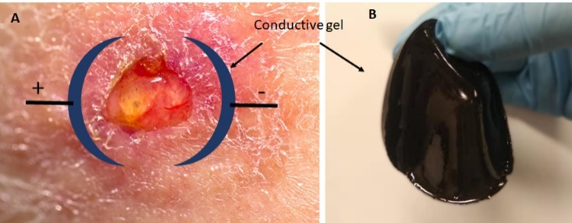
Figure 1. A: Illustration of how to electrically stimulate a skin ulcer; B: The conductive cryogel.
Conclusion: We prepared a conductive cryogel that has an auto-adhesive ability to the skin. The gel was soft and compliant to the contour of skin. This conductive gel may be used as electrode to apply electrical stimulation to skin wounds.

